THE WORLD’S FIRST MB&F LAB OPENS AT THE ICONIC RAFFLES HOTEL IN SINGAPORE

Singapore, 19 September 2022 — MB&F and The Hour Glass is proud to announce the opening of the first MB&F Lab in the world at the iconic Raffles Hotel in Singapore. This is the first iteration of the new MB&F Lab concept and marks an exciting new chapter for MB&F and The Hour Glass. The opening of the first MB&F Lab is also a testament to the maturity of watch collectors and connoisseurs in Singapore.

“Singapore, even though a small country, has garnered the largest community of MB&F collectors in the world.” Max Büsser, Founder and Creative Director of MB&F remarks, “This is as much due to the sophistication and passion for artisanal watches from the Singaporean public as to the incredible energy The Hour Glass Group has put into educating collectors about high-end independent artisanal watchmaking.”

This boutique is located on the first level of the Raffles Hotel Arcade and presents a new hybrid retail experience, similar to the M.A.D.Gallery, in a more intimate space.

The MB&F Lab in Singapore follows the recently revamped architectural identity of the M.A.D.Galleries. Its clean, crisp, gallery-like interiors in white provide the perfect canvas for the new interior design. Focal in the boutique is a giant reflective lens in blue, bespoke domed glass display cases for watches, accompanied by custom-made mid-century-inspired tables and matching furniture.

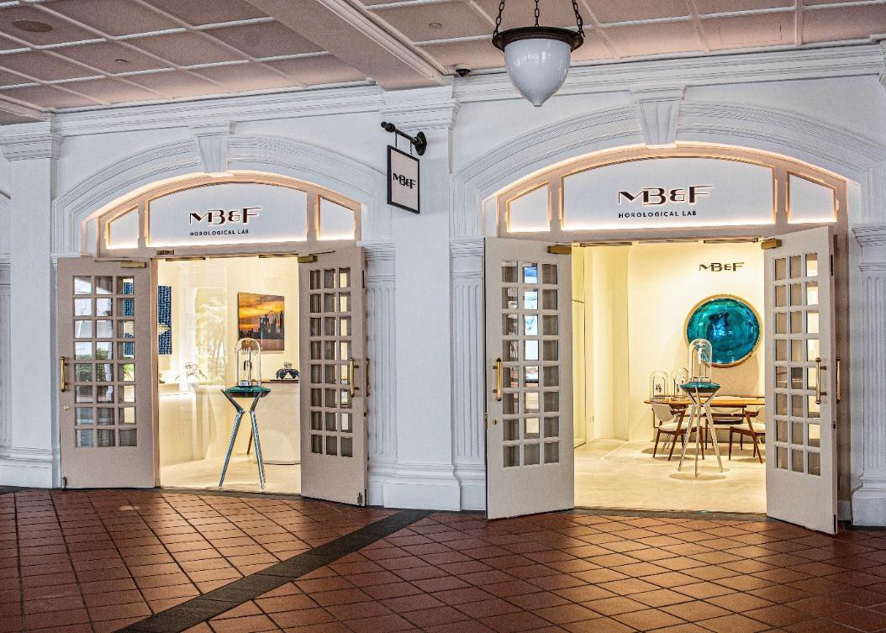
The new MB&F Lab inside Raffles Arcade marks an exciting new chapter for MB&F and The Hour Glass. Credit: The Hour Glass

MB&F LAB: A NEW HYBRID RETAIL CONCEPT
MB&F created the first M.A.D.Gallery in 2011 in Geneva as a platform to showcase MB&F Machines, MB&F Co-creations, along with carefully-curated kinetic and mechanical art pieces by various artists from around the world.

In collaboration with Swiss-based agency Voltige Design & Architecture, MB&F has redefined the interior design and architectural identity for its M.A.D.Galleries and the new MB&F Lab spaces. These will showcase MB&F Machines with a curated selection of kinetic art pieces, in more intimate spaces than a full-fledged M.A.D.Gallery.

A BESPOKE VISUAL MARKER
Distinct to this new architectural identity is a new bespoke visual marker: a giant blue reflective lens that is the focal point of the space. Evocative and eye catching against the white background, the lens plays with the geometric rules of reflections. “We came up with the idea of a central element, a sort of giant lens that would turn the world upside down with its reflections that move as you walk past,” Tyl Vergriete, co-founder of Voltige, explains. “It stands alone, but does not steal the attention from the other creations in the space.”

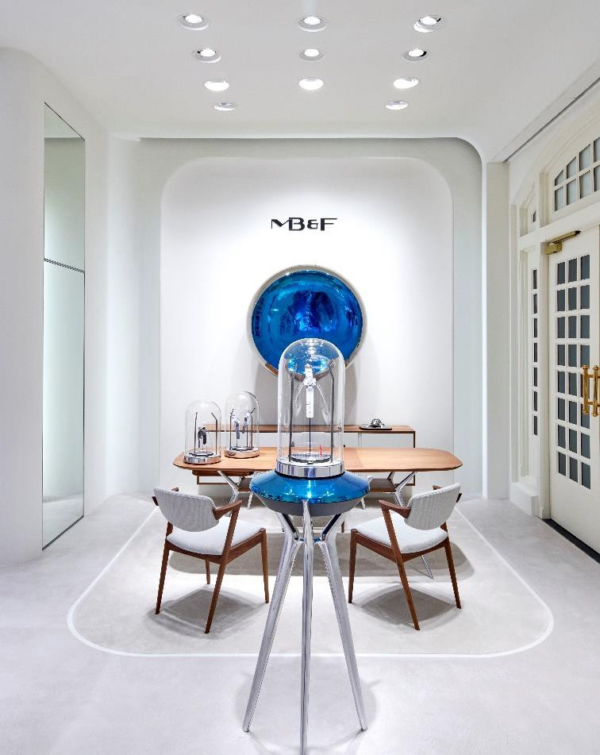
Manufacturing the lens was an incredibly challenging process, carried out by a French ceramics company that has been in operation for over 170 years. Tyl continues: “Working with different artisans was also an important part of the project as MB&F wanted this element of craftsmanship to be present throughout, just like it is with their watches.”
The MB&F Lab in Singapore follows the recently revamped architectural identity of the
M.A.D. Galleries with crisp, white interiors and a giant reflective lens in blue as a focal point for the boutique. Credit: The Hour Glass

DISTINCTIVE DOMED GLASS DISPLAY CASES
Where the vast majority of showcases are usually square glass boxes on four legs, the domed showcases at the MB&F Lab break away from this usual industrial geometry to create something unexpected, echoing MB&F creations. The glass domes are completed with a cast aluminium tripod-like stand and a blue ceramic disc, that matches the giant lens, recalling MB&F’s love for all things space-age.

Another major challenge was the fabrication of the glass domes of the showcases, reminiscent of the aesthetics of old science-fiction movies – and the domed sapphire crystals of MB&F Machines. Several criteria needed to be met, including an outstanding optical quality, a good level of security and the ability to access the watch easily. To avoid any structural element or visual disturbance, the glassmaker had to find a way to make a cut in the 5mm thick glass dome and then create a perfectly matching second piece of glass to serve as a door. A fully customized curved slider was designed to allow for the door to slide out while moving to the side in one easy motion.

CUSTOM-DESIGNED FURNITURE
The third key element of the new design is the furniture, which Max Büsser explains as “something I would like to have in my own home”. The result is an homage to the quality and know-how of furniture craftsmen of the 1950s and 60s. The main piece is a large table that has been modified by skilled carpenters so that it can display watches in recessed showcases embedded in the wooden surface. This watch display will take pride of place in the centre of the space and welcome the visitor to sit at the table and take the time of a conversation. Original mid-century chairs convey a sense of quality and elegance, both around the table and bar areas.

AN ICONIC LOCATION INSIDE RAFFLES SINGAPORE
Mention Singapore and an icon that comes to mind is the Raffles Hotel. This landmark hotel has witnessed the history of Singapore for the past 135 years. While the location of the new MB&F Lab within the Raffles Arcade may seem unexpected, it was a carefully considered choice. The arcade showcases a myriad of international and local brands, to collectively create a one-of-a-kind retail experience that goes beyond traditional brick and mortar shopping. The MB&F Lab will offer a novel retail experience, where inventive horological creations sit alongside ingenious pieces of mechanical art.

“A strong tree needs strong roots, and the Raffles very elegantly reminds us of that. It is a landmark not only for Singapore but for the whole world.” Busser explains, “I am therefore so happy that it will showcase the very first MB&F LAB, a concept which will see the opening of five more locations around the world over the next twelve months.”

HOROLOGICAL AND MECHANICAL ART SIDE BY SIDE
As the F in MB&F stands for Friends, it was only natural for MB&F to develop collaborations with artists, watchmakers, designers, and manufacturers they admire.
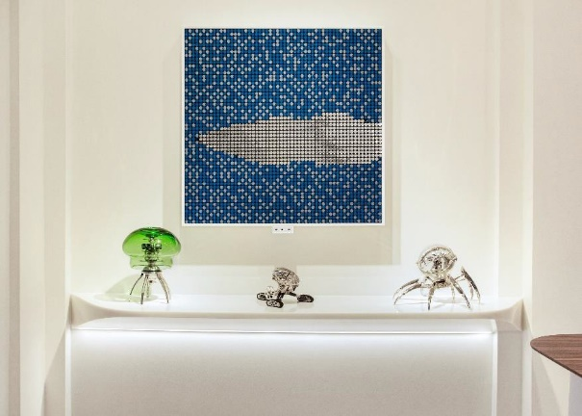
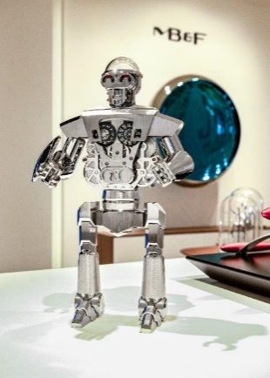

Left: The gallery-like space of the new MB&F Lab provides the perfect backdrop for kinetic artworks and MB&F’s creations, such as this “World Skies” by BREAKFAST and MB&F x L’Epée 1839 Co-creations Medusa, Grant, and Octopod (left to right). Right: The Balthazar clock, a MB&F x L’Epée 1839 Co-Creation at the new MB&F Lab. Credits: The Hour Glass

This brought about two new categories: Performance Art and Co-creations. While Performance Art pieces are MB&F machines revisited by external creative talent, Co-creations are not wristwatches but other types of machines, engineered and crafted by unique Swiss manufactures from MB&F ideas and designs. To give all these machines an appropriate platform, Büsser had the idea of placing them in an art gallery alongside various forms of mechanical art created by other artists, rather than in a traditional storefront. This brought about the creation of the first MB&F M.A.D.Gallery, and now also in the MB&F Lab in Singapore.

On display are the latest MB&F horological creations, including the Legacy Machine Split Escapement EVO and the ground-breaking LM Sequential EVO, as well as MB&F Co- Creations, including the Octopod, Medusa, and Balthazar clocks created with L’Epée 1839, and the MusicMachine 1 Reloaded with Reuge. There is opportunity to peruse specially curated works of art, such as the KB2 Utinam x Alain Silberstein clock, Frank Buchwald’s Nixie Machine III, ‘World Skies’ by BREAKFAST, and the Singapore edition of Marc Ninghetto’s ‘Solitude of a Machine’.

MB&F AND THE HOUR GLASS
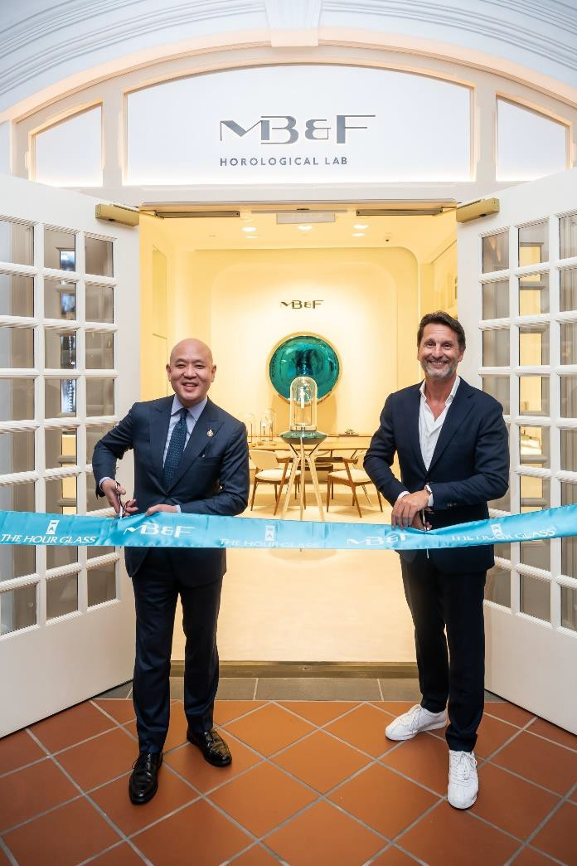
Michael Tay, Group Managing Director of The Hour Glass and Max Büsser, Founder and Creative Director of MB&F, at the official opening of the new MB&F Lab Singapore. Credit: The Hour Glass

The relationship between Max Büsser and The Hour Glass dates back well before Max Büsser founded his own company in 2005. The Hour Glass is proud to be a partner of MB&F since the very beginning. The opening of the first MB&F Lab in Singapore marks a new milestone in this long-term partnership.

Büsser says, “I have been working with The Hour Glass for soon 24 years. It has not only been a pleasure but a real privilege to be partnering with the Tay family and their fantastic teams. The opening of the MB&F LAB in Singapore is one more great step in our amazing journey.”

Established and with headquarters in Singapore, The Hour Glass exemplifies a passion for horology through designing uniquely immersive watch experiences delivered by team of highly knowledgeable watch specialists. With a growing network of over 50 boutiques across 12 key cities in the Asia-Pacific region, The Hour Glass continues its mission to advance watch culture, as it has done since 1979.

Says Michael Tay, Group Managing Director of The Hour Glass, “I first met Max in Singapore in 1999 and it is one of those rare relationships in my life where what started as a professional partnership has, over the past two decades, transformed into one of a lifelong friendship. I value Max because he is one of the few visionaries in the universe of contemporary horology

The Hour Glass is the Exclusive Retailer of MB&F in Singapore, Australia, Malaysia, and Thailand.

MB&F LAB SINGAPORE
328 North Bridge Road, #01-19, Raffles Hotel Arcade, Singapore 188719
Tel: 6550 2688
Opening Hours
Monday to Saturday:
11.00am to 8.00pm

Sunday & Public Holiday:
11.00am to 6.00pm

